**COLLABORATIVE PROJECT WITH INTEL**

**PROJECT TITLE : Business Contract Validation.**

**TEAM NAME :** **Mavericks**

**Team Mentor : Dr T V RAJINI KANTH, Professor & Head,**

**Department of CSE-AI&ML**

**Ph. No: 9849414375**

**Team Members : Laknaboina Prem Kiran** Roll no: 21311A6611 CSE-AIML(TL)

**Bareddy Vidhya Sree** Roll no: 21311A6617 CSE-AIML

**Ramisetti Deekshitha** Roll no: 21311A6632 CSE-AIML

**Samanuri Sri Harsha**  Roll no: 21311A6634 CSE-AIML

**Dadepogu Vishal Anup** Roll no: 21311A6661 CSE-AIML

**Institute Name** **:** **Sreenidhi Institute of Science and Technology**

**Yamnampet, Ghatkesar**

**Hyderabad - 501301**

**Date of submission :** **15 -07- 2024**

**ABSTRACT**

Business contract validation plays a crucial role in ensuring the integrity, compliance, and consistency of contractual agreements within organizations. This abstract explores the significance of contract validation, focusing on the systematic classification of contract clauses and the detection of deviations from established templates.

Business contracts are legal documents. The first task is to parse these documents so that have a structure to them. Determine the key details within the contract document. Every contract has clauses and sub-clauses. The next step is to classify the contents of the parsed documents to these clauses. Typically, a contract has an associated template to it, and it is important to determine the deviations from that template and highlight them.

Detecting deviations from standard templates involves comparing drafted contracts against predefined templates or model agreements. Deviations can stem from negotiated changes, unique circumstances, or inadvertent errors, necessitating careful scrutiny to ensure adherence to legal requirements and best practices.

**INTRODUCTION**

In today's fast-paced business environment, the integrity and compliance of contractual agreements are paramount. The Business Contract Validation project aims to streamline the process of validating and managing business contracts to ensure they adhere to predefined templates and compliance standards. This project involves parsing legal documents, extracting and classifying key details into relevant clauses and sub-clauses, and identifying any deviations from standard templates. By automating the validation process, the project enhances accuracy, reduces the risk of non-compliance, and provides a robust framework for managing contractual obligations efficiently. This innovative approach leverages advanced data processing techniques to transform unstructured contract data into structured, actionable insights, ensuring that all business agreements are transparent, consistent, and enforceable.

**MOTIVATION**

The motivation behind rigorous business contract validation stems from the paramount need for organizations to uphold legal compliance, mitigate risks effectively, and ensure operational efficiency. Contracts serve as binding agreements that govern relationships between parties, and ensuring their compliance with laws, regulations, and internal policies is crucial to avoiding legal liabilities and disputes. By systematically reviewing and classifying contract clauses, organizations can identify potential legal pitfalls early in the process. This proactive approach not only minimizes legal risks but also enhances the organization's ability to navigate complex regulatory landscapes with confidence.

Moreover, consistency and standardization in contract language and terms are essential for clarity and mutual understanding. Predefined templates and models provide a structured framework that promotes consistency across agreements. This standardization streamlines contract management processes, reduces ambiguities, and facilitates quicker decision-making. Clear classification of clauses further enhances operational efficiency by enabling stakeholders to easily locate and interpret specific terms, obligations, and rights within contracts.

Effective contract validation also plays a crucial role in risk management by proactively identifying deviations from standard templates. These deviations can arise from negotiated changes, unique business requirements, or inadvertent errors. By detecting and assessing these deviations early on, organizations can implement appropriate risk mitigation strategies, thereby preventing potential disputes and operational disruptions down the line.

Furthermore, rigorous contract validation promotes governance best practices within organizations. It ensures transparency and accountability in contractual agreements by documenting findings and adhering to established procedures. This transparency not only builds trust among stakeholders but also aligns with corporate governance standards, demonstrating a commitment to ethical business practices and regulatory compliance.

Lastly, contract validation processes contribute to continuous improvement within organizations. By analyzing deviations and documenting feedback, organizations can refine templates, update policies, and enhance contract drafting practices over time. This iterative approach fosters a culture of learning and adaptation, enabling organizations to stay agile in response to evolving legal requirements and business dynamics.

Top of Form

The Intel Industrial Training initiative Unnati Program helps the students in getting the flavour of Industrial View of the work planning, interaction and guidance of Intel Team and friendly competing with other students from different parts of the world.

**DATA SOURCES**

ContractNLI is a dataset for document-level natural language inference (NLI) on contracts whose goal is to automate/support a time-consuming procedure of contract review. In this task, a system is given a set of hypotheses (such as “Some obligations of Agreement may survive termination.”) and a contract, and it is asked to classify whether each hypothesis is entailed by, contradicting to or not mentioned by (neutral to) the contract as well as identifying evidence for the decision as spans in the contract.

In the first step of our project, we focused on initial data collection. We aimed to gather commercial contracts from a variety of contract types, including affiliate agreements, agency agreements, license agreements, marketing agreements, service agreements, supply agreements, and promotion agreements.

To begin, we went through the internet to identify different types of contracts. This involved extensive online research to understand the various categories and their specific characteristics. Once we had a clear list of contract types, we manually searched for data sources. We meticulously explored websites, online databases, and repositories to find relevant contract examples.

The process was thorough and required a keen eye for detail to ensure that we captured a wide range of agreements within each contract category.

**PYTHON LIBRARIES USED IN THE PROGRAM**

**Llama-index**: The Llama Index (now known as LangChain) is a popular framework for building Retrieval-Augmented Generation (RAG) applications, which are systems that enhance the capabilities of language models by integrating them with external knowledge sources.

**Streamlit**: Streamlit is an open-source Python library used for building interactive web applications for data science and machine learning projects. It allows developers to create UI elements directly in Python scripts.

**IPython**: IPython is an interactive Python shell that provides features like tab completion, object introspection, and rich media display. It's often used for interactive computing and data exploration.

**Llama-index-embeddings-gemini**: This suggests a specific implementation or module related to generating embeddings (representations) of data associated with llama indexing, possibly within a framework or project named "Gemini."

**Llama-index-llms-gemini**: Similar to the previous item, this may indicate another aspect or module within the llama indexing project named "Gemini," possibly focusing on LLMS (Llama Learning Management System) aspects or components.

**Pypdf**: This likely refers to PyPDF2, a Python library for working with PDF files, including reading, merging, splitting, and extracting text and metadata.

**Transformers**: Transformers is a popular library by Hugging Face for natural language processing (NLP) tasks, especially leveraging transformer models like BERT, GPT, and others for tasks such as text classification, translation, and summarization.

**ARCHITECTURE**

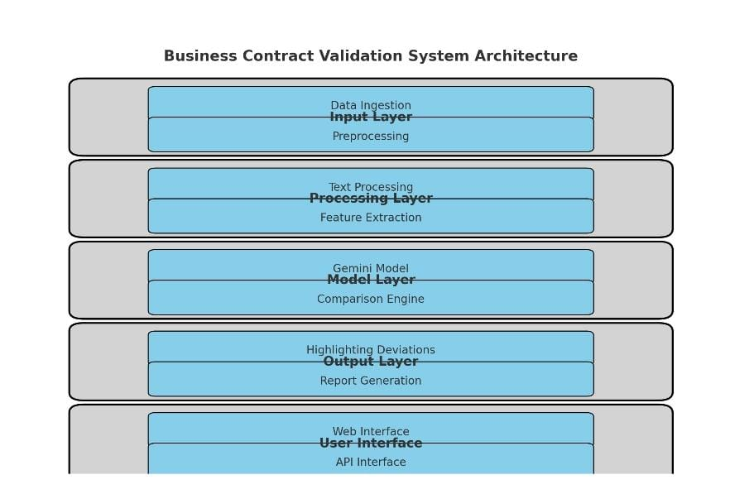

**Fig 1**

**RESULTS**

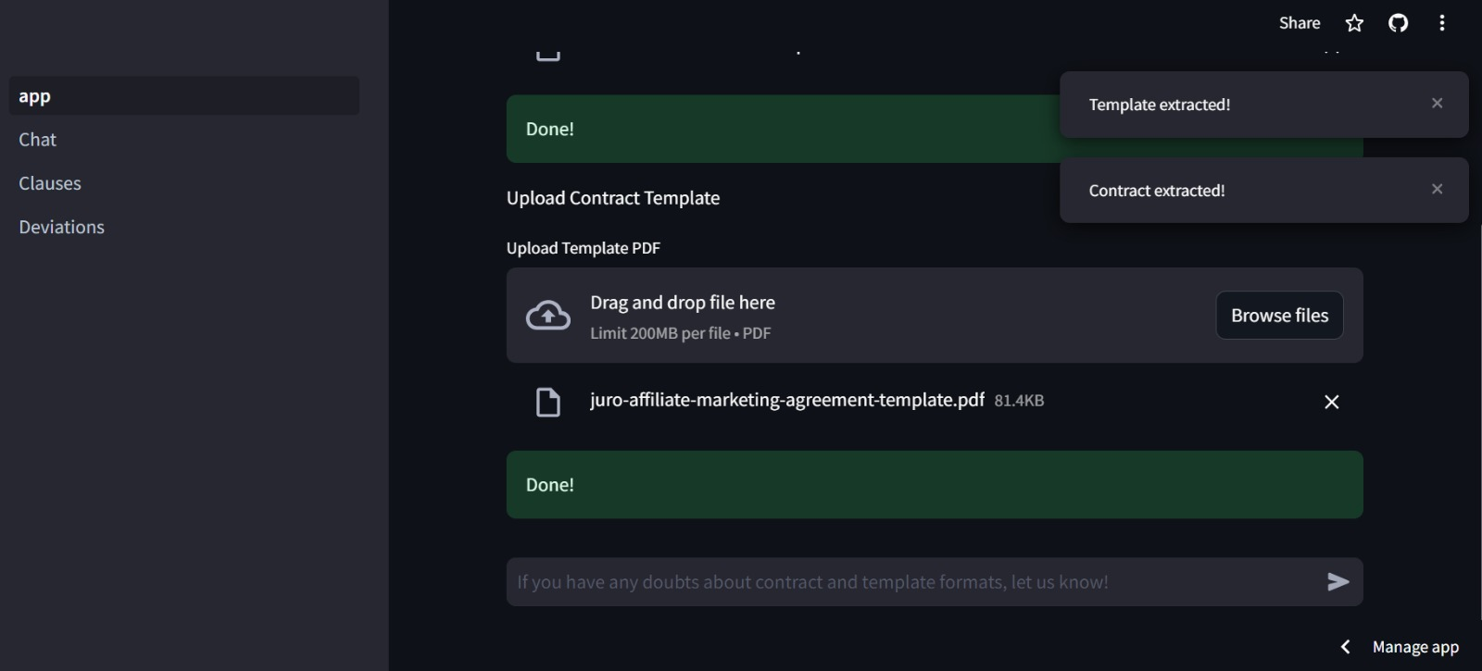

Fig -2

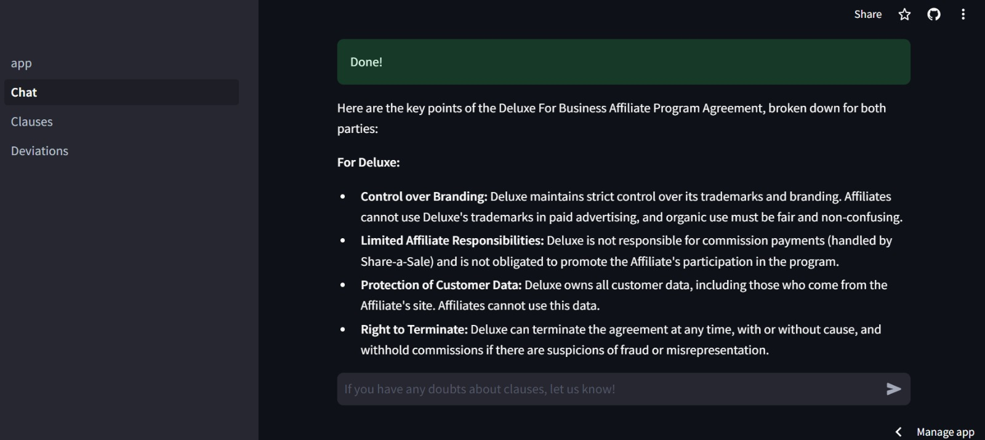

Fig-3

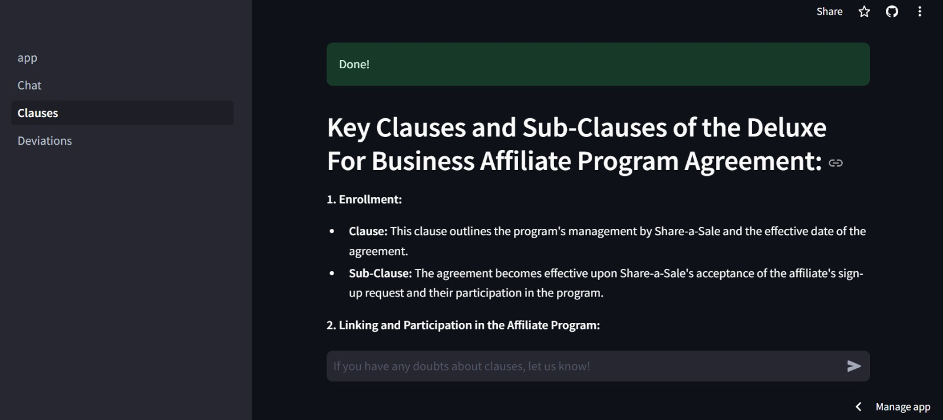

Fig-4

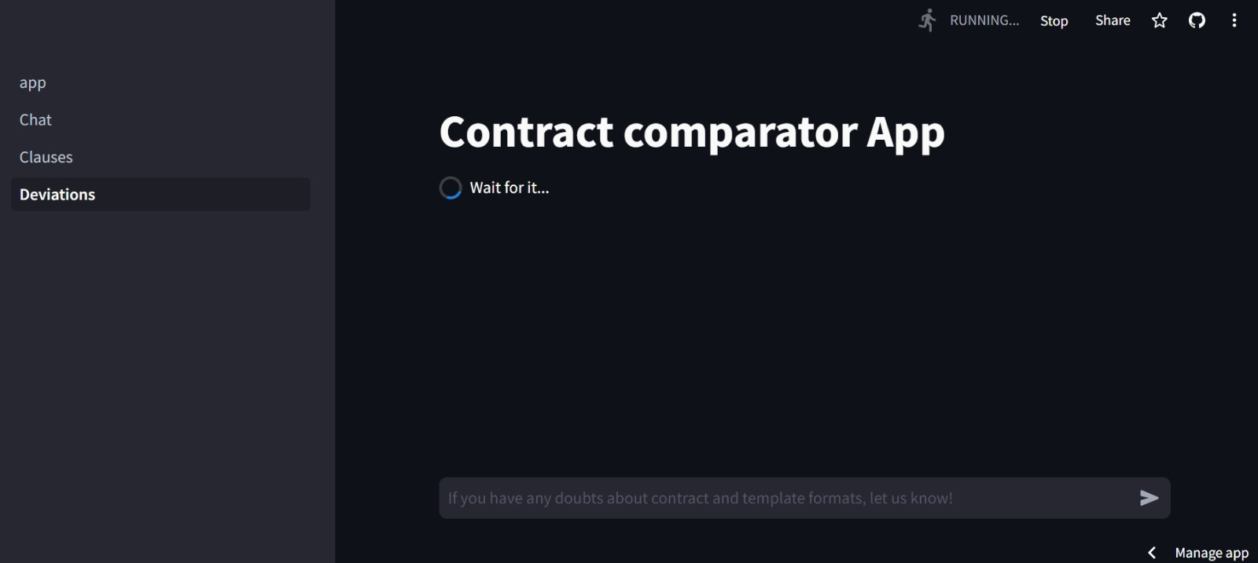

Fig 5

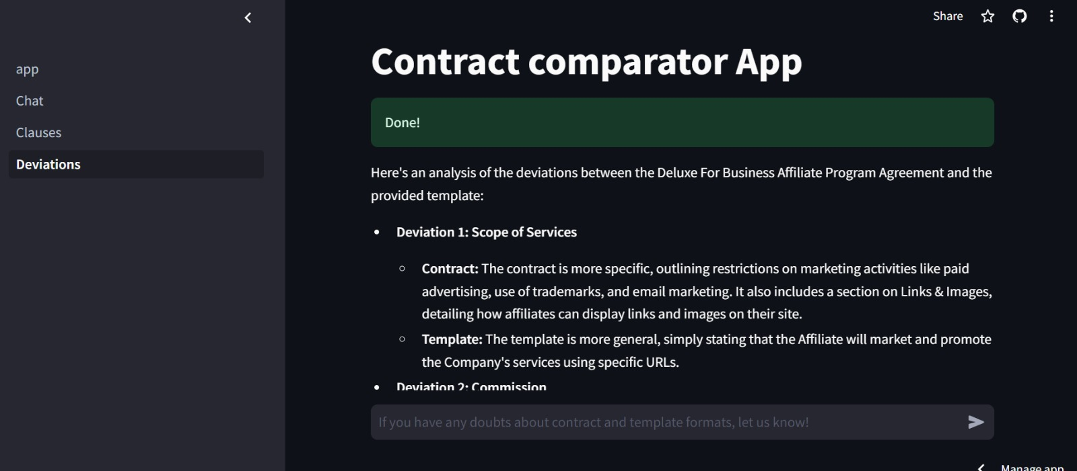

Fig 6

**CONCLUSION**

In conclusion, business contract validation, which includes classifying contract clauses and identifying deviations from templates, ensures clarity, compliance, and risk management. By categorizing clauses and addressing deviations promptly, organizations enhance contract effectiveness, mitigate legal risks, and maintain transparent and trustworthy business relationships. This systematic approach supports operational efficiency and strengthens contractual foundations, crucial for sustainable business practices and regulatory compliance.

**FUTURE SCOPE**

Looking ahead, the future of business contract validation will see significant advancements driven by automation, AI, and blockchain technologies. Automation will streamline processes like clause classification and deviation detection, enhancing accuracy and efficiency. AI and NLP will enable deeper contract analysis and insights extraction. Blockchain's adoption will ensure secure, transparent contract execution through smart contracts. Enhanced visualization tools, predictive analytics for risk management, and integrated compliance monitoring will further strengthen contract management practices, fostering transparency and agility in business dealings. These innovations promise to revolutionize how organizations manage contracts, ensuring compliance, minimizing risks, and supporting sustainable growth.

**REFERENCES**

# Retrieval-Augmented Generation for Large Language Models: A Survey

# (December 2023)

# Gemini 1.5: Unlocking multimodal understanding across millions of tokens of context

**(March 2024)**

**SOURCE CODE AND CONFIGURATION FILES**

**Live Web Site [Demo]**